Company: GE (General Electric)

1. What is the name of the outside auditing firm for your company?
The name of the outside auditing firm for GE, is KPMG. Their headquarters is in Zug, Switzerland.

2. How long after the company's year-end did the auditors issue their opinion?

3. Who bears primary responsibility for maintaining effective internal control over financial reporting? How can you tell?

4. Does it appear the company has adequate internal control procedures? How can you tell?

5. By how much did the company's cash balance change from the beginning of the year to the end of the year?

6. What type of instruments does the company consider to be cash equivalent?

7. Calculate the cash ratio. How does this ratio compare with the industry?

8. What is the balance of accounts receivables for the company?

9. Compute the acid-test ratio. If the current liabilities came due immediately, could the company pay them?

10. Compute the accounts receivable turnover at year-end.

11. Compute days sales in receivables at year-end.
12. Based on the acid-test ratio, accounts receivable turnover, and days sales in receivables, how does the company compare to the industry?

Example ONLY: DON’T USE THE COMPANY NIKE.

I just added this to show how they SOLVED some of their answers

NIKE

1. What is the name of the outside auditing firm for your company? PRICEWATERHOUSECOOPERS LLP- Portland, Oregon (https://investors.nike.com, 2017).

2. How long after the company's year-end did the auditor's issue their opinion? Approximately 50 Days after fiscal year-end which ended 31 May 2017 for Nike (https://investors.nike.com, 2017).

3. Who bears primary responsibility for maintaining effective internal control over financial reporting? Chairman, President and Chief Executive Officer & Chief Financial Officer How can you tell? Nike’s 2017 Annual Report Form 10k, Item 8 part 2, page 95 under “Management’s Annual Report on Internal Control Over Financial Reporting (https://investors.nike.com, 2017)”. It explains management’s role in Nike’s internal control of financial reporting (https://investors.nike.com, 2017).

4. Does it appear the company has adequate internal control procedures? Yes. How can you tell? Nike’s 2017 Annual Report Form 10k, Item 8 part 2, page 95, gives a descriptive break-down of the company’s internal controls of its finances (https://investors.nike.com, 2017).

5. By how much did the company's cash balance change from the beginning of the year to the end of the year? Nike cash and equivalents went from $3,138,000 in 2016 to $3,808,000 in 2017 (https://investors.nike.com, 2017).

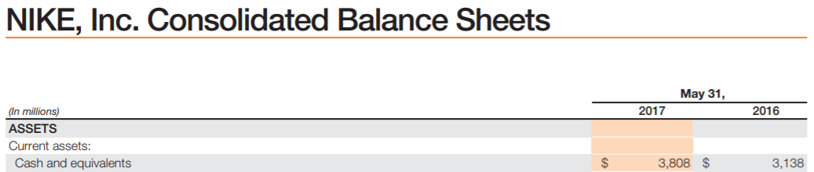

6. What type of instruments does the company consider to be cash equivalent? Nike considers all these assets cash equivalents: Short-term investments, Accounts receivable, net, Inventories, & Prepaid expenses and other current assets (https://investors.nike.com, 2017).
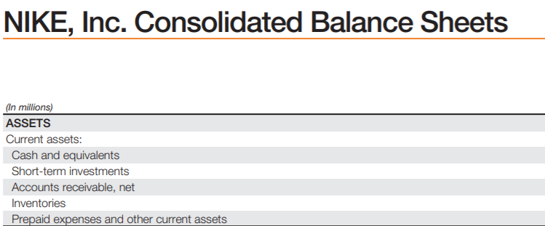

7. Calculate the cash ratio. as of
31 May 2017- 3808/5474
= 6956 or .70
31 May 2016- 3138/5358
=.5856 or .59
How does this ratio compare with the industry? According to industry standards in the textbook a cash ratio below one is considered safe (Miller-Nobles, 2016).

8. What is the balance of accounts receivables for the company? $3,677, 000 as of 31May 2017 which is up 8.8% from 2016 (https://investors.nike.com, 2017).

9. Compute the acid-test ratio. If the current liabilities came due immediately, could the company pay them?(Cash/cash equivalent+ short-term investments+ net current receivables)/ Total current Liabilities. We have (4,249,000+996,000+3,498,00)/6,040,000
=8,743,000/6,040,000= 1.4475 or 1.45 (https://investors.nike.com, 2017). The acid ratio test for Nike is safe. Our text states anything above 1.00 on acid ratio test is considered safe (Miller-Nobles, 2016).

10. Compute the accounts receivable turnover at year end.
(3,498,00+3,677,000)=7,175,000/2=3,587,500. Cost of sales is amount is 5,411,000 (https://investors.nike.com, 2017).
Now let’s take 5,411,000/3,587,500 to get our accounts receivable turnover ratio (Miller-Nobles, 2016). We get 15.08 at year end (Miller-Nobles, 2016).

11. Compute days sales in receivables at year end. (365 days/Accounts Rec. turnover ratio)
=365/15.08= 24.02 or 24 days to collect on its accounts receivable (Miller-Nobles, 2016).

12. Based on the acid-test ratio, accounts receivable turnover, and days sales in receivables, how does the company compare to the industry? Based on the aforementioned ratios Nike’s ratios are on par or slightly lower according to our text (Miller-Nobles, 2016). The company easily maintains steady profit margins and is a safe bet for an investor.

References
https://investors.nike.com. (2017, May). https://investors.nike.com/investors/news-events-and-reports/?toggle=topBanner. Retrieved from https://investors.nike.com/investors/news-events-and-reports/?toggle=topBanner: https://investors.nike.com/investors/news-events-and-reports/?toggle=topBanner
Miller-Nobles, T. M. (2016). Horngren's Financial & Manigerial Accounting-THE FINANCIAL CHAPTERS- FIFTH EDITION. New York: Pearson.

